NOTICE OF A VACANCY IN THE OFFICE OF BOROUGH COUNCILLOR

NOTICE IS HEREBY GIVEN that pursuant to Section 87(2) of the Local Government Act 1972, Jephthe Doguie, formerly a member of the above Borough Council has resigned. A vacancy now exists in the office of councillor for the Eastleigh Central Ward.
Requesting a by-election is triggered by local government electors requesting an election to take place. This requires two local government electors within a principal local authority giving notice to the Returning Officer, Eastleigh Borough Council, Eastleigh House, Upper Market Street, Eastleigh SO50 9YN.
Upon receipt of a request for the vacancy to be filled, an election will be held to fill the vacancy within 35 working days (computed in accordance with the Act).

Nicholas Roland Tustian
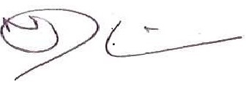
Returning Officer
Dated: 4 January 2022

