User guide – External candidates

Contents
1. Creating a login and accessing the recruitment portal 1
2. Viewing current vacancies 2
3. Viewing the status of your applications 2
4. Updating your details in the My Profile tab 3
5. Uploading your CV to the Attachments tab 3
6. Applying for a vacancy 4
7. What happens next 5

You will need to create a log in and register your details to apply for a vacancy with the Council and manage/view your applications. You can also get a regular update of the latest #TeamEBC job vacancies by signing up for Your Weekly Borough News on our website.

1. Creating a login and accessing the recruitment portal

- To create a log in please click on the green ‘Login’ button on the main page

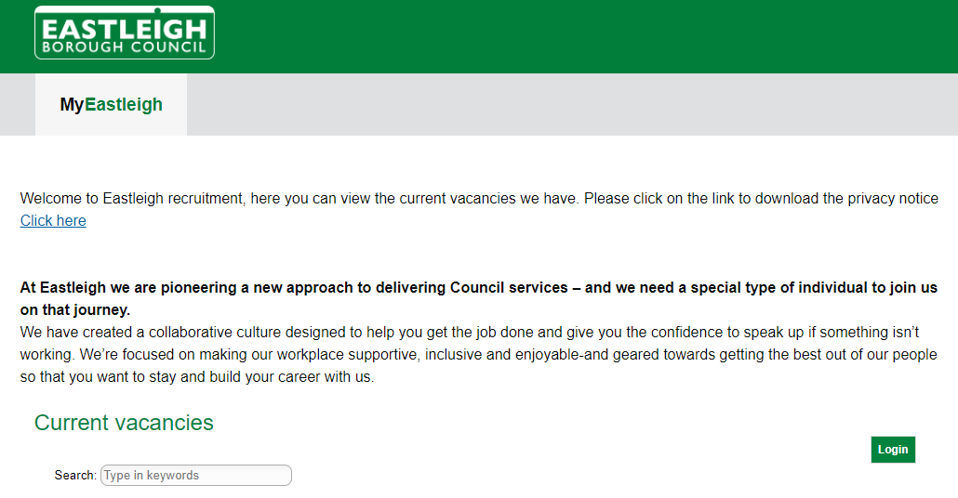
- Click on ‘Register’ to create a login

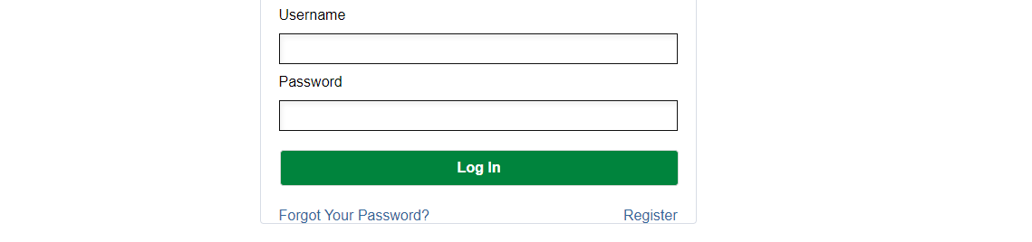

- Enter your first name, surname, and email address and click submit
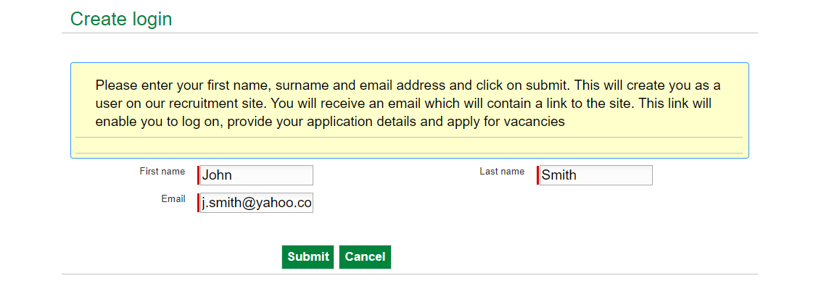

- You will receive an email from RecruitmentLEX (please check your junk/spam folder). Click the link within the email to create a password. Once you have set your password you will be able to login using your username (your email address), and your password.

2. Viewing current vacancies

- Once logged in you can view the current vacancies. To view the details of each vacancy please click ‘View’ and to make an application please click ‘Apply’

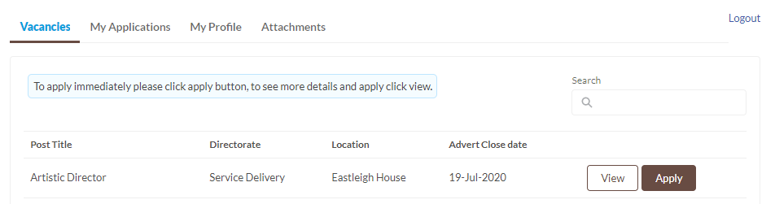

3. Viewing the status of your applications

- On the ‘My Applications’ tab you can view the status of your applications, view draft applications and submitted applications, and withdraw your applications.

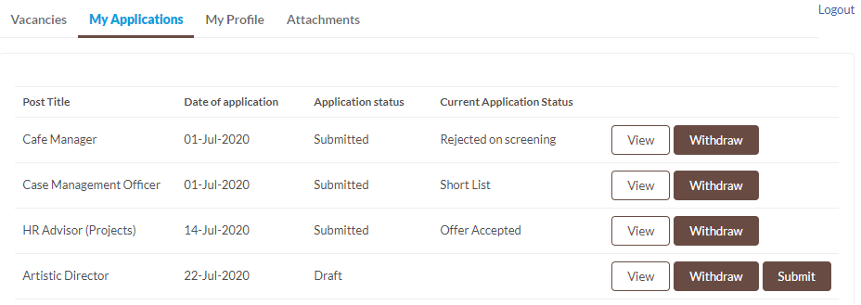

4. Updating your details in the My Profile tab

- On the ‘My Profile’ tab you can enter your details and edit these at any point.

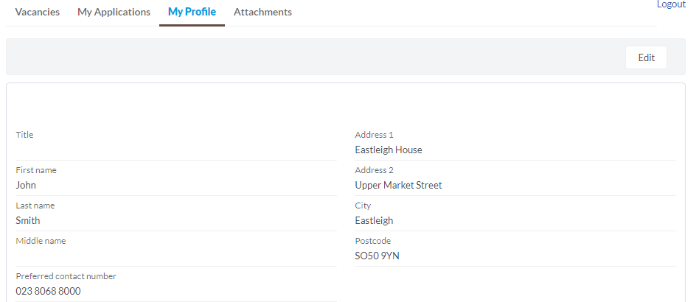

5. Uploading your CV to the Attachments tab

- On the ‘Attachments’ tab you can upload your CV here by clicking on the ‘Upload Files’ button. Please note that this will be attached to all vacancies you apply for.

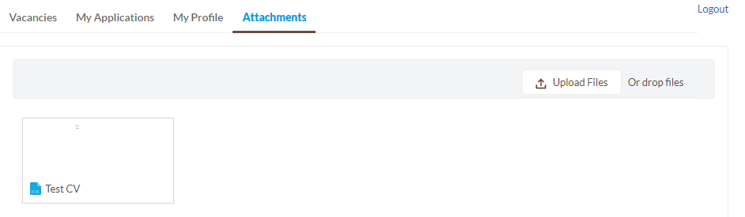
- To upload a new version of your CV or delete the file, click on the document to show a preview of the file. Click on ‘Upload New Version’ to replace the existing file with the new file you wish to upload. To delete the file, click on the down arrow and click on the ‘Delete’.

6. Applying for a vacancy

- Once you are logged in you can apply for a vacancy by clicking on the ‘Apply’ button next to the vacancy listing or when you view the vacancy, the ‘Apply’ button is on the top right-hand side.

- A new screen will pop up with the application form for you to complete. Please scroll down and complete each section. You can then either click ‘Save draft’ and upload your CV using the Attachments tab at the top of the page. Or you can click ‘Attach CV & save draft’ to upload your CV directly to the application form. Please ensure you attach the correct file as you will not be able to amend this. You can then view your application under the ‘My applications’ tab.
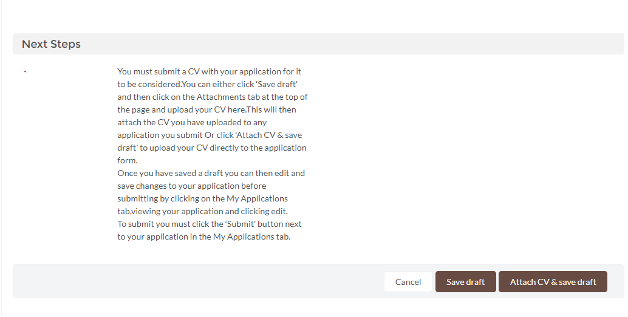

- Before you submit your application, you will be able to make edits. View your application via the ‘My Applications’ tab and then click the ‘Edit’ button. Once you have made your changes click ‘Save’.

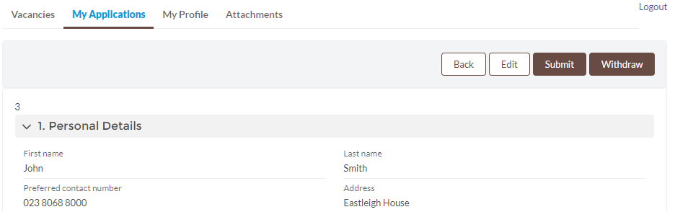

- Before you submit your application, please ensure that you have attached your CV either by uploading it via the ‘Attachments’ tab or clicking ‘Attach CV & save draft’ on the application form and uploading your CV.

  - To submit your application please click the ‘Submit’ button next to your application listed on the ‘My Applications’ tab or at the top of page when you are viewing your application.

  - The status of your application will then be updated from ‘Draft’ to ‘Submitted’.

What happens next

  - If you have not been selected for interview you will receive an email from HR to confirm this and encourage you to apply for any further vacancies with us.

  - If you have been invited to interview you will receive an email from HR to confirm your interview date and time. You will also be informed if there is also a test to complete or you are required to give a presentation. To confirm your attendance please reply to the email as soon as possible.

  - If you are unsuccessful following your interview you will receive an email from HR to confirm this decision and we encourage you to apply for any further vacancies with us.

  - If you are successful following your interview you will be notified by phone by either the hiring manager who interviewed you, or HR.

If you have any queries, please email hrinfo@eastleigh.gov.uk

