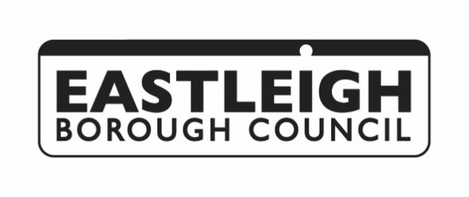

Botley Submitted Neighbourhood Plan Consultation
RESPONSE FORM
Under Regulation 15 of the Neighbourhood Planning (General) Regulations 2012, Botley Parish Council has submitted their Neighbourhood Plan to Eastleigh Borough Council. In accordance with Regulation 16, Eastleigh Borough Council would like to invite comments from individuals and organisations on the submitted Neighbourhood Plan. Your comments should address whether the plan meets the basic conditions. These are that the plan:

- Must be appropriate having regard to National Policy
- Must contribute to the achievement of sustainable development
- Must be in general conformity with the strategic policies in the development plan for the local area
- Must be compatible with human rights requirements

This consultation runs from Wednesday 4 September to Wednesday 16 October 2024.
In order for your comments to be taken into account at the examination, and to keep you informed of the future progress of the plan, your contact details are needed. All comments will be made publicly available and identifiable by name and organisation (where applicable).
Please fill in your details in the boxes below:
Full Name:

Organisation represented (where applicable):

Address and postcode:

Email address:

Telephone number:

Please state which part(s) of the Botley Neighbourhood Plan (i.e. section, objective or policy) or supporting document your representation refers to:

Do you support, support with modifications, object, or wish to comment on this part of the Plan? (Please tick one answer)
Support Support with modifications Object Comments

Please add your response below and continue on a separate sheet if necessary:

Please state whether you would like to be notified of the Council’s decision on whether to accept the Examiner’s recommendation and future progress with the Neighbourhood Plan proposal:

Yes No

Please email this form to planning.policy@eastleigh.gov.uk or post it to Planning Policy, Eastleigh Borough Council, Upper Market Street, Eastleigh, SO50 9YN.

Data Protection Statement
The information collected in this response form will be published in a Consultation Statement which will form part of the evidence for an independent examination of the plan and its supporting documents. By responding you are accepting that your response, and the information within it, will be made available to the public. Your contact details will not be published.

