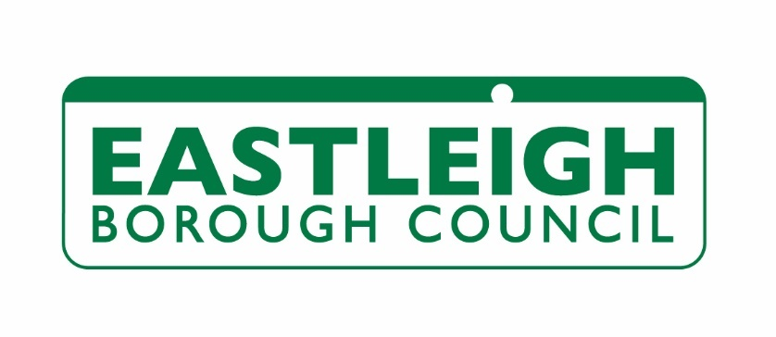**Eastleigh Borough Council**

**Eastleigh House**

**Upper Market Street**

**Eastleigh**

**SO50 9YN**

**Greenhouse Gas Emissions Report: 2022-2023**

1. **Introduction**

Eastleigh Borough Council adopted the Department for Energy and Climate Change (DECC) request that, as from July 2011, Local Authorities report greenhouse gas (GHG) emissions from their own estates and services using a standard DEFRA methodology and format. When Eastleigh Borough Council Declared a climate emergency in 2019 it updated its reporting to include the Greenhouse Gas Protocol, a more up to date methodology.

This report covering the period of 2022/23 has been updated to follow the Greenhouse Gas Protocol for reporting emissions from electricity. The protocol recommends the use of dual reporting of market based and location-based electricity emissions. Market based emissions are derived from the contractual agreement with an energy supplier, for example a green energy tariff. Location based electricity emissions use the national grid average and reflect the amount of GHG emissions that would have been generated in lieu of a green energy tariff.

In line with the GHG protocol reporting methodology solar energy exported to the grid has been removed as a ‘carbon credit’, as this energy will be used elsewhere and may be reported it could constitute double counting, previous years shown in this report have been amended for comparison.

1. **Emissions Summary**

Table 1 summarises Eastleigh Borough Council’s GHG emissions (tCO2e) for the past years against the base year of 2018/19 using the new Climate & Environmental Emergency methodology. Electricity figures have been amended to reflect green energy tariff. Scope 3 calculations for commuting, procurement and working from home have been estimated for all years.

|  |  |  |  |  |  |
| --- | --- | --- | --- | --- | --- |
|  | **2018/19** | **2019/20** | **2020/21** | **2021/22** | **2022/23** |
| Scope 1 (Gas, Fuel) | 1771 | 1913 | 1571 | 1406 | 1271 |
| Scope 2 (Elec, Water) | 213 | 154 | 46 | 31 | 28 |
| Scope 3 (Travel, Procurement, WFH) | 7409 | 5579 | 7288 | 5911 | 6595 |
| **Total net emissions** | **9393** | **7647** | **8901** | **7348** | **7894** |
| **%reduction from 2018/19** |  | **-18%** | **-5%** | **-22** | **-16%** |

Table – CEE GHG emissions summary tCO2e (not weather corrected)

1. **Company Information**

Eastleigh Borough Council is a district Council within Hampshire providing a range of services to a resident population of 140,000. The registered address is Eastleigh House, Upper Market Street, Eastleigh, Hampshire, SO50 9YN

1. **Reporting Period**

This report is for the financial year 1 April 2022 to 31 March 2023.

1. **Changes in Emissions**

As new hybrid working practice have become established then patterns consistent with the last report are emerging.

Gas (Scope 1) and electricity emissions (Scope 2) are similar to pre-Covid 19 levels, although the green energy tariff reduces the impact of increased electricity emissions.

Business and staff commuting travel (Scope 3) remain lower than pre-Covid 19 levels but emissions from working at home (Scope 3) have increased.

Procurement (Scope 3) has been estimated for the last five years using the same methodology. It is the largest single source of emission for the Council and is unstable with an increase in the last year.

The carbon intensity of electricity continues to reduce as the grid becomes ‘greener’. The carbon intensity of water has also reduced by around 50% in the last two years the reporting factors have been updated.

Bulk fuel (scope 1) was lower than the previous year as hydrotreated vegetable oil displaced diesel usage.

1. **Measuring and Reporting approach**

The majority of this report is based on the DEFRA “Environmental reporting Guidelines”, which includes mandatory greenhouse gas emissions reporting guidance.

In response to the Climate and Environmental Emergency the Council updated its reporting following the Greenhouse Gas Protocol and begun reporting all emissions related to the climate. In addition to the DEFRA reporting, Table 1 now factors in:

* Staff Commute to work
* Working from home
* Procurement

1. **Organisational Boundary**

We have used the financial control approach as recommended in the guidance to define our organisational boundary. Our scope includes emissions from buildings and transport used for the delivery of our services.

1. **Operational Scope**

Table 3 shows what is included in each scope measured in tCO2e.

|  |  |  |  |  |  |
| --- | --- | --- | --- | --- | --- |
|  | **2018/19** | **2019/20** | **2020/21** | **2021/22** | **2022/23** |
| **Scope 1 (Fuel Combustion)** |  |  |  |  |  |
| Gas | 672 | 772 | 538 | 714 | 691 |
| Fuel | 1098 | 1141 | 1028 | 692 | 580 |
| **Total** | **1771** | **1913** | **1566** | **1406** | **1271** |
|  |  |  |  |  |  |
| **Scope 2 (Indirect emissions)** |  |  |  |  |  |
| Electricity – location based (not included in calculation) | 454 | 390 | 274 | 507 | 425 |
| Electricity - market based | 182 | 125 | 17 | 15 | 13 |
| Street Lighting | 15 | 14 | 13 | 10 | 7 |
| Water | 16 | 16 | 17 | 6 | 8 |
| **Total** | **213** | **155** | **46** | **31** | **28** |
|  |  |  |  |  |  |
| **Scope 3 (Indirect other)** |  |  |  |  |  |
| Business Travel | 31 | 32 | 16 | 20 | 23 |
| Staff Commuting Travel1 | 376 | 368 | 111 | 118 | 111 |
| Procurement1 | 6979 | 5156 | 6941 | 5719 | 6410 |
| Working from Home | 23 | 22 | 221 | 55 | 51 |
| **Total** | **7409** | **5579** | **7288** | **5911** | **6595** |
|  |  |  |  |  |  |
| **Total emissions** | **9393** | **7647** | **8901** | **7348** | **7894** |
|  |  | -18% | -5% | -22 | -16% |

Table - Breakdown of Scope 1,2 & 3 tCO2e (not weather corrected)

The CO2e conversion factors used in calculating the GHG have been taken from the Government emission conversion factors for greenhouse gas company reporting.

The figures have not been weather corrected.

1. **Geographical Breakdown**

All Eastleigh Borough Council’s activities are in the UK.

1. **Targets**

The Council has declared a Climate Emergency and will put in place measures to ensure that the Council’s own operations and functions are carbon neutral by 2025,

1. **Base Year**

The baseline year for carbon neutral by 2025 is 2018/19.

1. **Intensity Measurement**

We have chosen the intensity measurement of tCO2e per full time equivalent (FTE) member of staff and per £m income as most relevant to local government.

|  |  |  |  |  |  |
| --- | --- | --- | --- | --- | --- |
|  | **2018/19** | **2019/20** | **2020/21** | **2021/22** | **2022/23** |
| **tCO2e per FTE** | 21.04 | 15.84 | 17.96 | 14.30 | 16.18 |
| **tCO2e per £m income** | 135.27 | 113.09 | 109.23 | 108.85 | 122.19 |

1. **External Assurance Statement**

The Council has not received independent external assurance over our reported emissions.

1. **Carbon Offsetting**

The Council has not purchased any carbon offsets

1. **Green Tariffs**

The Council purchases green electricity for all of its operational sites from EDF.

1. **Electricity Generation**

The Council has a programme of installing solar PV whenever feasible

|  |  |  |  |  |  |
| --- | --- | --- | --- | --- | --- |
|  | **2018/19** | **2019/20** | **2020/21** | **2021/22** | **2022/23** |
| **kWh Consumed** | 133,152 | 118,895 | 133,546 | 128,741 | 158,505 |
| **kWh Exported** | 215,081 | 229,483 | 249,695 | 197,115 | 225,773 |
| **Total Generated** | **348,233** | **348,379** | **383,241** | **325,856** | **384,773** |