**Project update (February 2025)**

To date we have planted 14 sites throughout Bishopstoke with a mix of fruiting trees and shrubs. With the help of volunteers and ‘Green Smile LTD’ we are continuing to develop these sites so they are more dynamic in terms of the food they provide for us and also for pollinators. During February 2025 will be laying pollinator plant seed on each of the sites – we would really appreciate your help by staying off the newly planted sites while the seed germinates and hopefully in spring these gardens will start to create a new vista in your neighbourhood. Once the wildflowers are established, we would then welcome your support in helping with the upkeep, planting and picking fresh organic produce from these sites.

These sites are to be flagged with new signs which have been generated using amazing art work from Fair Oak and Stoke Park Schools, so you can clearly see which sites we are developing – watch this space!

We also have plans afoot to plant up new areas in Bishopstoke, Fair Oak and Horton Heath. The first is the open space on Dean Road, Fair Oak, which will be planted with edible trees and shrubs and wildflowers, closely followed by planting oaks with an understorey of pollinator flowers to bolster the character of ‘Oak Walk’ on Fair Oak Road.

Concept design and impression of Dean Road open space:

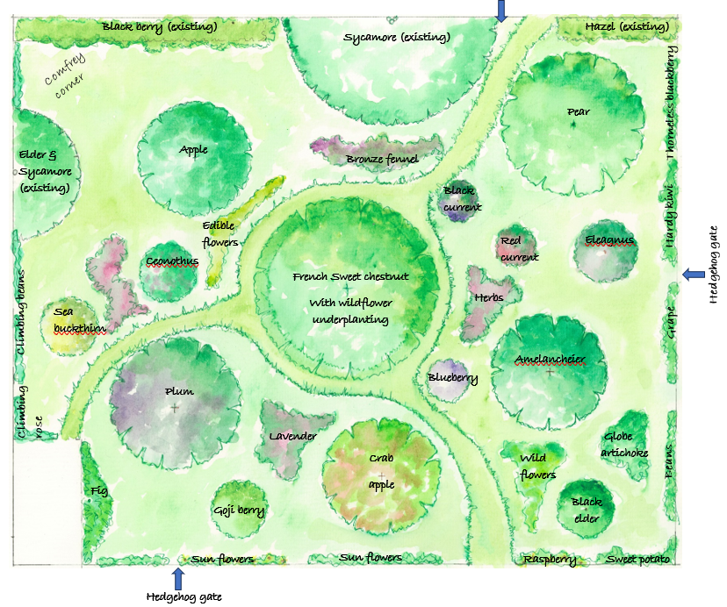

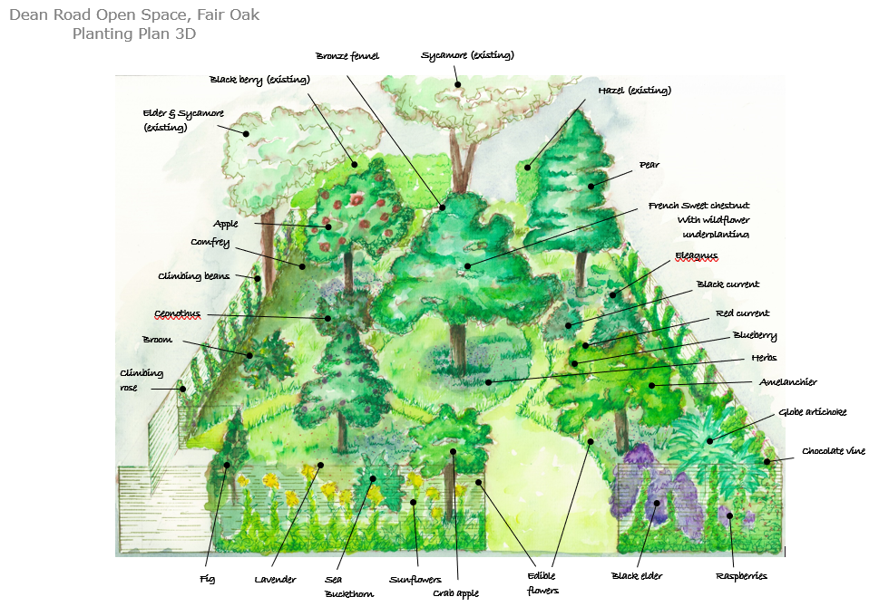

If you live close to Dean Road open space and would like to comment on the designs or get involved with planting, watering and picking fresh organic food from the garden, please contact Siobhan at Fair Oak Parish Council [siobhan.strand@fairoak-pc.gov.uk](mailto:siobhan.strand@fairoak-pc.gov.uk) or if you live in Bishopstoke [clerk@bishopstokepc.org](mailto:clerk@bishopstokepc.org) or Becky at Eastleigh Borough Council [treeandbee@eastleigh.gov.uk](mailto:treeandbee@eastleigh.gov.uk) – We would love to hear from you!