
Community
Building

Places where people can gather are vital to communities, which is why Eastleigh Borough Council wants to support community groups in their bid to make their buildings more energy efficient, costing less to run.

We will consider any project that results in a carbon reduction and the amount we give is dependent on the carbon savings achieved to a maximum of 50% of the cost.

Eligibility
We welcome applications from charities or not-for-profit making organisations that
- Manage a building within Eastleigh Borough.
- The building is likely to be in community use, by the said organisation, for at least 10 years.
- The project results in a carbon saving in Eastleigh Borough.
- Your organisation is willing to take part in publicity in the local community and display an A4 sized plaque inside the building in a prominent position.

An application can only be submitted once the property has had a quote. Grant offers will be allocated on a first come, first served basis when an application is received and until funds are exhausted. The offers are valid for 6 months.

Work should not begin until you have received confirmation of a grant from Eastleigh Borough Council.

The grant can be claimed once the project is complete. Eastleigh Borough Council will normally pay any financial assistance awarded directly to the contractor.

Contact details
For any questions and completed application forms please use the following contact options:
Contact | Giles Gooding
Telephone | 023 8068 8274
Email | Sustainability@eastleigh.gov.uk
Address | Sustainability  Eastleigh Borough Council  Eastleigh House  Upper Market Street  Eastleigh  SO50 9YN
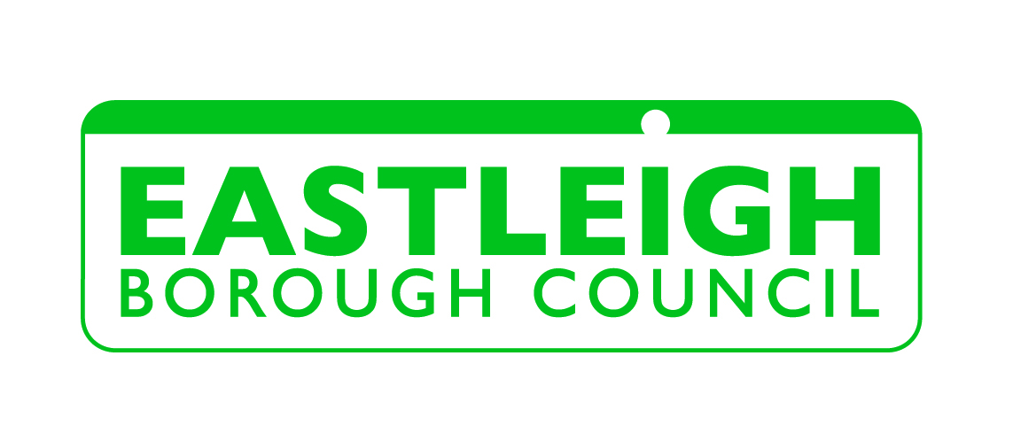
Grant Application
Community Buildings
Applicant Details
Name
Address
 |  |  |  |  | Postcode
Email |  |  |  |  | Telephone
Organisation
Registered Charity No
Briefly describe the organisation and the work it carries out
About the Community Building
Address
Address |  |  |  |  | Postcode
Does the organisation own the building?

Has the owner given permission for you to apply for this grant?

Briefly describe the building including its age, size, type of construction and any modifications done to it since it was constructed?
Which other groups use your building?
In a typical week when is the building currently used and by how many people?
The Funding request
Briefly describe what this grant application is for
Preferred Contractor
Quote |  | £ | Funding requested |  |  |  |  | £
Where is the remainder of the funding coming from?
We expect you to get at least two comparable quotes. Please state what the other quotes are and why you are using your preferred contractor.
To work out the carbon saving of the project please give us details of the expected energy savings and the life of the measures. Contact Eastleigh Borough Council if you have any queries.
Please ensure the following are also included with the application
A copy of the quotations
Permission from Owner
Signature (Write ‘By Email’ for applications submitted by email)
Signed |  |  |  | Date

