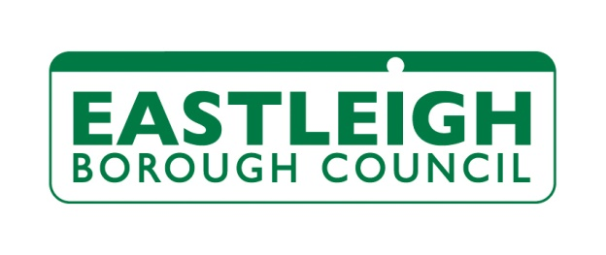

Occupational Therapy Enquiry
Please fully complete the below form including which, if any, benefits are in payment and return it by email to dfg@eastleigh.gov.uk
Date of enquiry:

Name:

Address including post code:

Telephone number(s):

Email address:
(Please state if none)

Any communication difficulties or preferences?
If you wish us to liaise with someone else please state their name, telephone number, email address (if any) and relationship to you.

Date of birth:

What adaptation(s) do you feel would be beneficial? (for example, a stair-lift, level access shower facility):

Are you currently awaiting assessment or having any ongoing support from any health or social care service (e.g. district nurse, community care team, occupational therapist)?

Details of any health issues or disability affecting every-day life (e.g. any difficulties with mobility, steps or stairs, any walking aids used, any difficulties with any activities of daily living):

Any other relevant information:

Please specify if you own your property, rent (private or social), and state whether you are claiming any benefits.
If there are no benefits in payment, please also complete a financial enquiry form which can be found on our webpage for DFGs and send both forms in together as this will speed up your enquiry.

Eastleigh Borough Council are committed to your privacy. We will use the information on this form in order to contact you to arrange an Occupational Therapy assessment, if one is necessary. The information may then be used to refer you for a grant if adaptations to your home are required. Please refer to our full Privacy Notice at www.eastleigh.gov.uk/privacy

